Nama : Meuthia Bronthe

NIM : 09010182327012

Kelas : MI3A

Mata Kuliah : Praktikum Jaringan Komputer

* **KONFIGURASI ROUTING RIP**

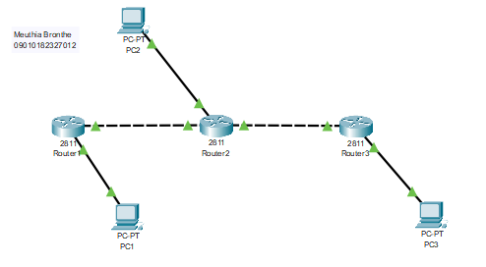

Buatlah IP Address di PC

|  |  |  |  |  |
| --- | --- | --- | --- | --- |
| **NO** | **NAMA DEVICE** | **ALAMAT** | **NETMASK** | **GATEWAY** |
| 1 | PC1 | 192.168.1.10 | 255.255.255.0 | 192.168.1.1 |
| 2 | PC2 | 192.168.2.10 | 255.255.255.0 | 192.168.2.1 |
| 3 | PC3 | 192.168.3.10 | 255.255.255.0 | 192.168.3.1 |

**ROUTER 1**

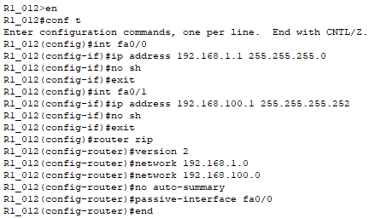

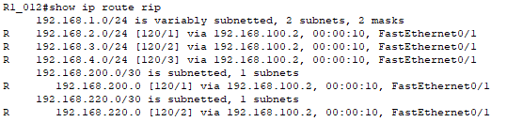

**ROUTER 2**

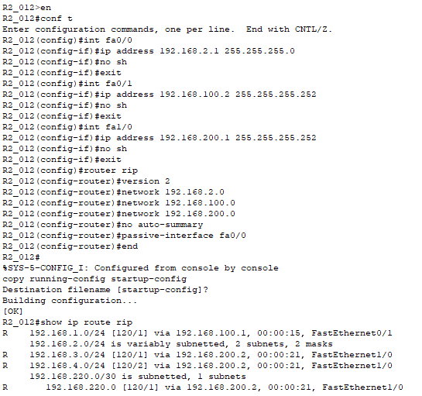

**ROUTER 3**

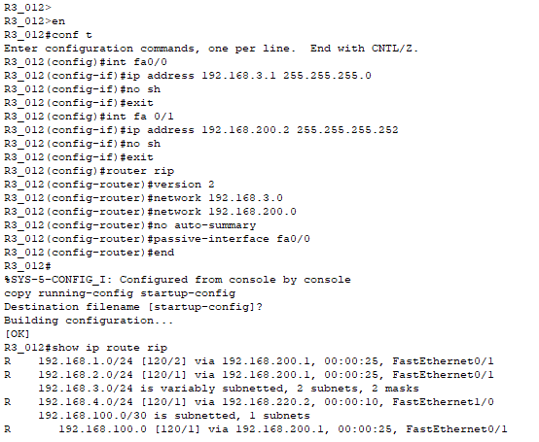

Melakukan PING dan Traceroute

|  |  |  |  |  |
| --- | --- | --- | --- | --- |
| **NO** | **SUMBER** | **TUJUAN** | **HASIL** | |
| **YA** | **TIDAK** |
| 1 | PC1 | PC2 | YA | - |
| PC3 | YA | - |
| 2 | PC2 | PC1 | YA | - |
| PC3 | YA | - |
| 3 | PC3 | PC1 | YA | - |
| PC2 | YA | - |

**PC 1 > PC 2, PC 3**

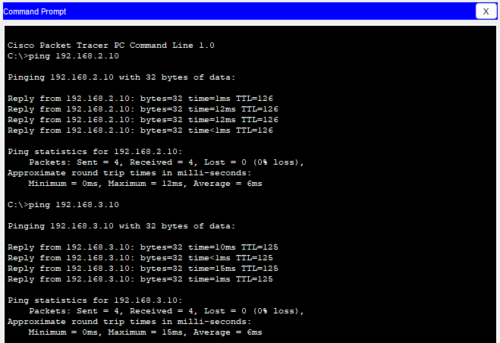

**PC 2 > PC 1 & PC 3**

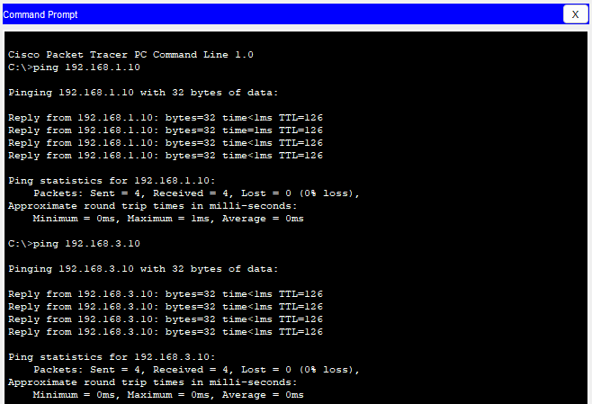

**PC 3 > PC 1 & PC 2**

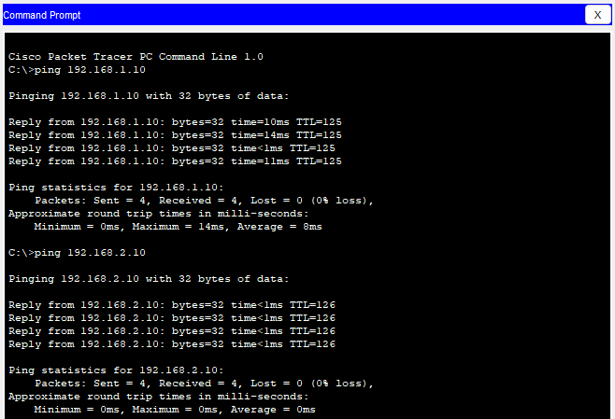

Tambahkan satu Router yaitu Router 4 dan PC yaitu PC4, dimana Router 4 terhubung ke Router 3 dan PC 4 terhubung ke Router 4

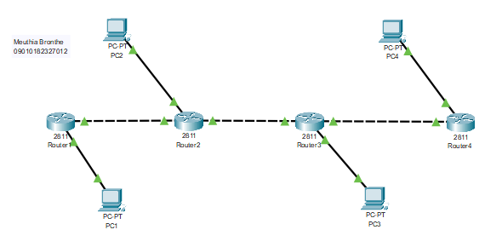

**Konfigurasi Router 3 ke Router 4**

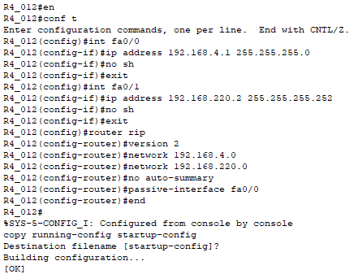

**ROUTER 4**

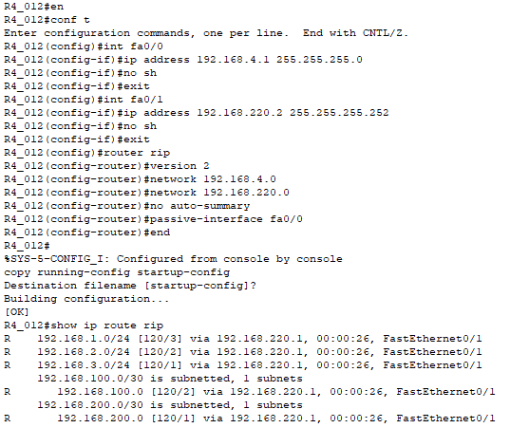

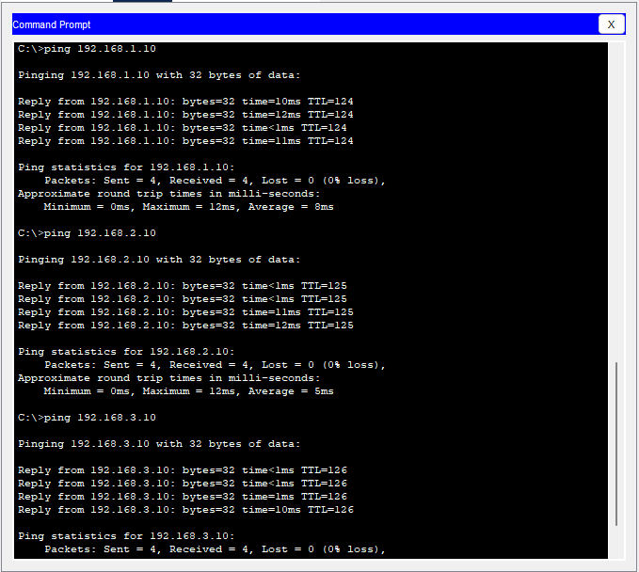

* **KONFIGURASI ROUTING EIGRP**

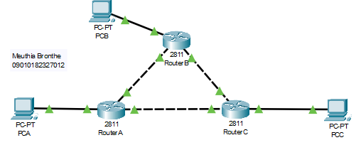

**Buatlah IP Address di PC**

|  |  |  |  |  |
| --- | --- | --- | --- | --- |
| **NO** | **NAMA DEVICE** | **ALAMAT** | **NETMASK** | **GATEWAY** |
| **1** | **PCA** | **192.168.1.10** | **255.255.255.0** | **192.168.1.1** |
| **2** | **PCB** | **192.168.2.10** | **255.255.255.0** | **192.168.2.1** |
| **3** | **PCC** | **192.168.3.10** | **255.255.255.0** | **192.168.3.1** |

**ROUTER A**

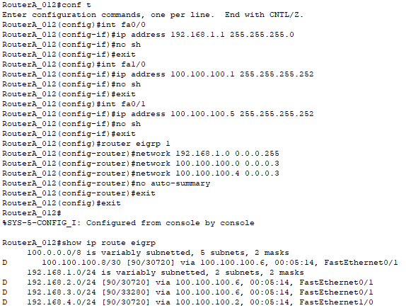

**ROUTER B**

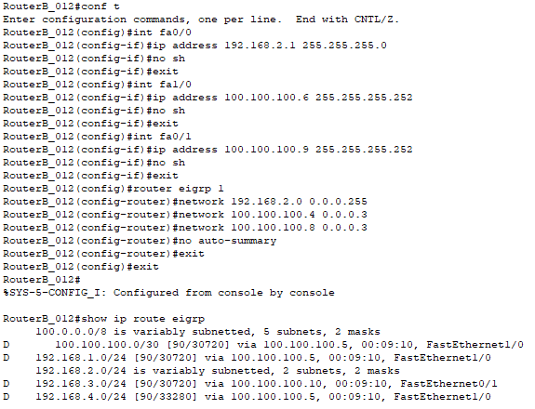

**ROUTER C**

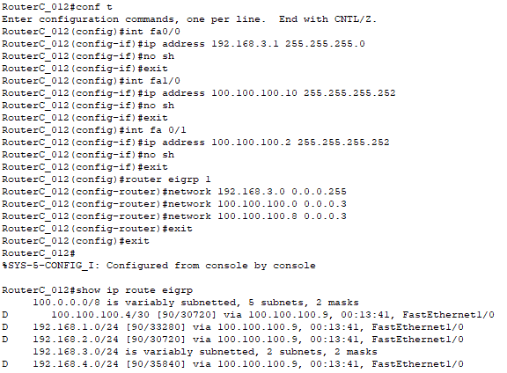

**Melakukan PING dan Traceroute**

|  |  |  |  |  |
| --- | --- | --- | --- | --- |
| **NO** | **SUMBER** | **TUJUAN** | **HASIL** | |
| **YA** | **TIDAK** |
| **1** | **PC1** | **PC2** | **YA** | **-** |
| **PC3** | **YA** | **-** |
| **2** | **PC2** | **PC1** | **YA** | **-** |
| **PC3** | **YA** | **-** |
| **3** | **PC3** | **PC1** | **YA** | **-** |
| **PC2** | **YA** | **-** |

**PCA > PCB, PCC**

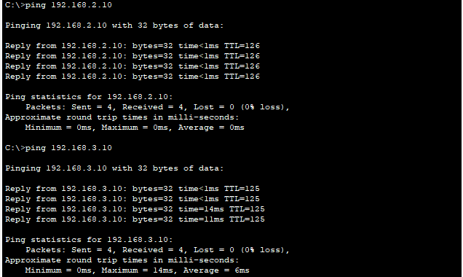

**PCB > PCA, PCC**

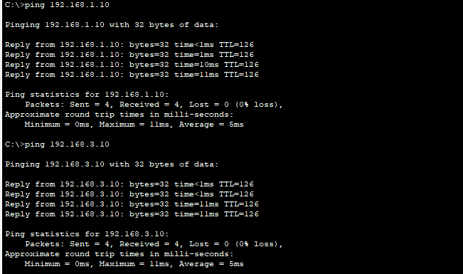

**PCC > PCA, PCB**

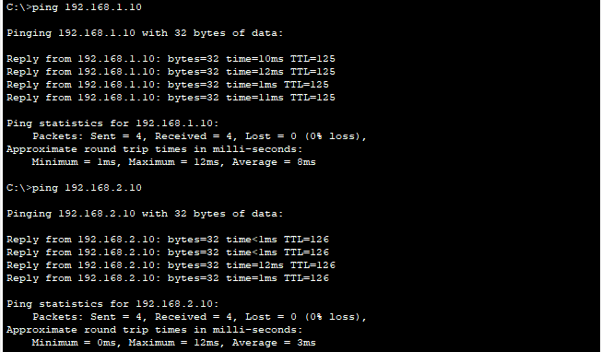

Putuskan koneksi pada Router A ke Router C, lalu tambahkan satu Router yaitu Router D dan PC yaitu PCD, dimana RouterD terhubung ke Router A dan Router C

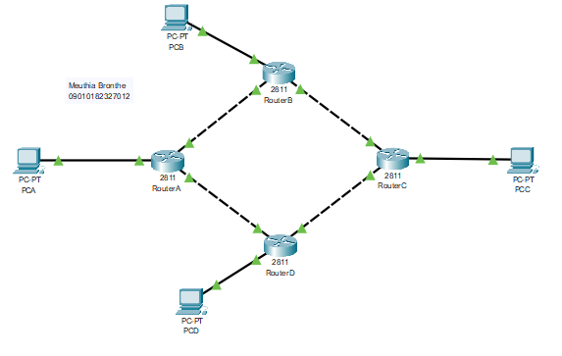

**ROUTER D**

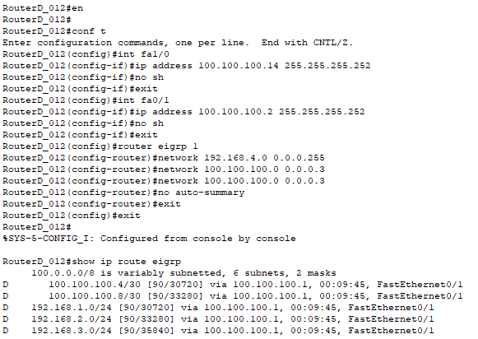

**PCD > PCA, PCB, PCC**

